EXPERIMENT 22 – TOWERS OF HANOI

AIM
To write a Prolog program to solve the Towers of Hanoi problem using recursion.

ALGORITHM
- Start the program with the number of disks.
- If there is one disk, move it directly to the destination.
- Move N-1 disks from source to auxiliary.
- Move the largest disk from source to destination.
- Move N-1 disks from auxiliary to destination.

PROGRAM
hanoi(1, From, To, _) :-
write('Move disk from '),
write(From),
write(' to '),
write(To),
nl.

hanoi(N, From, To, Aux) :-
N > 1,
N1 is N - 1,
hanoi(N1, From, Aux, To),
write('Move disk from '),
write(From),
write(' to '),
write(To),
nl,
hanoi(N1, Aux, To, From).

OUTPUT

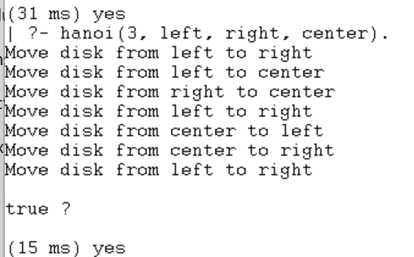

RESULT
Thus, the Towers of Hanoi problem was successfully solved using Prolog recursion.

